TJ, §§11-12
Explain the distinction between (1) and (2) that Rawls draws in the prefatory remarks to this chapter.

- What are the two principles? (p. 53)

  - What are the ambiguous phrases in the principles?

  - Why do you think Rawls does not require equal distribution? Wouldn’t think that parties gathered behind a veil of ignorance would divide the economic pie equally?

  - What does it mean to say that the principles are arranged in serial order? What is the problem that besets intuitionism? How does the serial ordering enable Rawls to avoid that problem?

  - Can you give an example of a society that has made the trade-off Rawls says serial ordering precludes on p. 55? (See this article.) Does serial ordering impose an implausibly strong requirement?

  - What liberties are covered by the first principle? Why does Rawls exclude the right to own the means of production and the unlimited right to contract?

  - What are primary goods? What is a plan of life? Are the primary goods things every rational person wants? Rawls will measure how well off people are by measuring the amount of primary goods they have. Is this a more or less plausible way of measuring well-being than the amount of utility someone enjoys?

  - What does Rawls give as the only reason for circumscribing basic liberties (p. 56)? Is he right or are there other valid reasons for the restriction of liberty?

  - Explain the distinction between allocation and distribution that Rawls draws on pp. 56 and 77.

- We have seen that there are two ambiguous phrases in the second principle. These give rise to four interpretations of that principle. Let’s look at the first three:

  - Natural liberty = formal equality of opportunity + the principle of efficiency

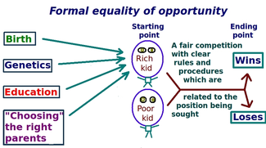
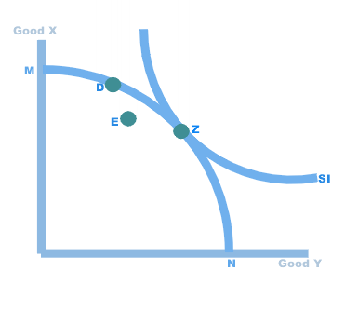
    - what is "formal equality of opportunity"?

    - Now let's turn to the principle of efficiency:

      - when is an allocation of goods efficient?

      - explain figures 3 and 4. why might point D in figure 4 be superior to point C? what is an "interpersonal cardinal interpretation of the axes"?

      - what is the principle of efficiency as applied to the basic structure?

      - Why can't the principle of efficiency alone serve as a principle of justice?

    - How does natural liberty constrain the principle of efficiency?

    - what is the problem with the system of natural liberty?

  - Liberal equality = substantive equality of opportunity + the principle of efficiency

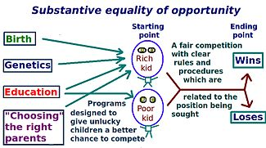

    - According to substantive equality of opportunity, two people with equal ability and willingness to expend effort will face the same life prospects. (So there should be an arrow from “Genetics” to both “Rich kid” and “Poor kid”). Thus Liberal Equality avoids the problem with Natural Liberty.

    - What does Rawls mean by saying "it may be worthwhile to recall the importance of preventing excessive accumulations of property and wealth"?

    - What other programs might be required to implement substantive equality of opportunity? (See Other Mandatory Programs)

    - suppose Liberal Equality works perfectly. There’s still a problem. What is it?

  - Natural aristocracy – “an ideal feudal system might try to fulfil the difference principle” (TJ p. 64n12)

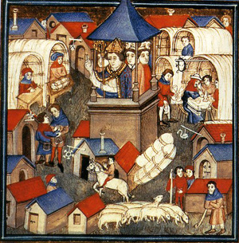

  - What does Rawls mean by saying that liberal equality and natural aristocracy are "unstable"? is he right?

  - Why doesn’t Rawls offer these interpretations to the parties in the OP and argue against them there?

  - What does Rawls mean when he implies that we want an interpretation of the two principles “which treats everyone equally as a moral person”? (p. 65)

To see a fascinating on-going study of equality of opportunity in the US, click here.

